

# **Get Started: Registration Basics**

# **Training Documentation**

Banner 9

Updated: 4/21/2021

## 1. Type SFAREGS in the Search box and press Enter.

1a. The Select Printers (SOADEST) form will appear the first time   
 you access SFAREGS after logging into Banner. Click the Exit   
 icon to continue to SFAREGS.

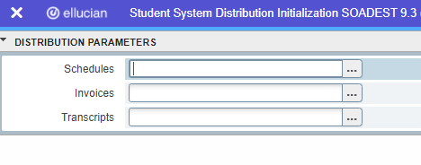

#### Entering Courses on SFAREGS

1. Enter Term and Student ID Number or Name.
2. Press Go

3a. Check for Holds (a “Y” will appear in the Holds field).   
***NOTE: the originating department must clear the hold before registration.***

3b. Check for Eligible Status: A student must be **EL**igible to register.

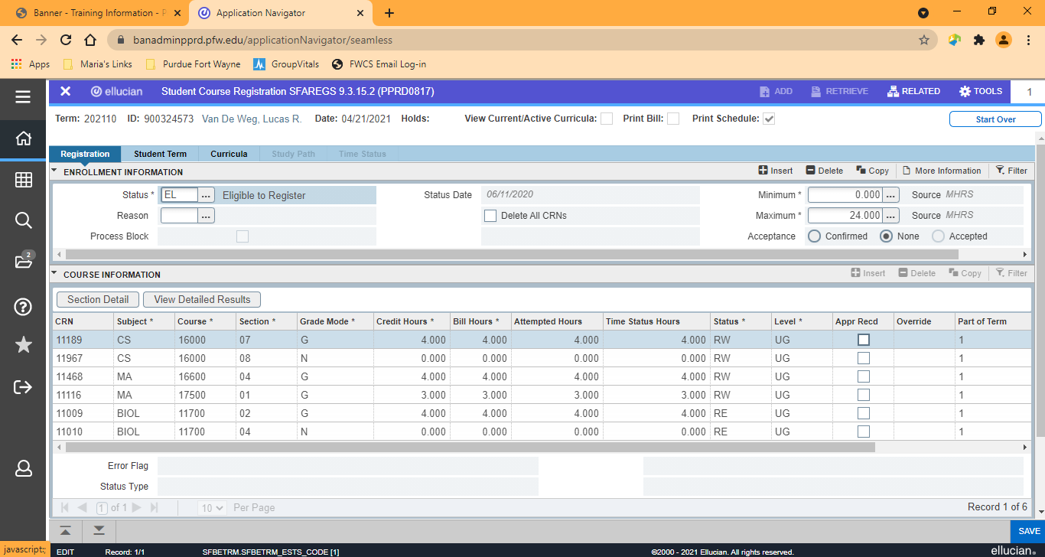

**#8 Enter CRNs. F9 or click arrow to search.**

**#3b Check for eligible status here**

**#3a Student has a HOLD if there is a Y.**

1. “Next Block” (ctrl-pgdn) to activate the course information section.
2. Enter the Course Reference Numbers (CRNs); depress Enter or Tab.
3. If you don’t know CRN, click on the ellipses in the CRN field, click on “Search for Sections.” (see screenshot below) This will take you to SFQSECM, this is a query form where you can search by several different options (subject is normally the easiest option). Once you find the CRN you want, click on the section, and click Select in the lower right-hand corner.

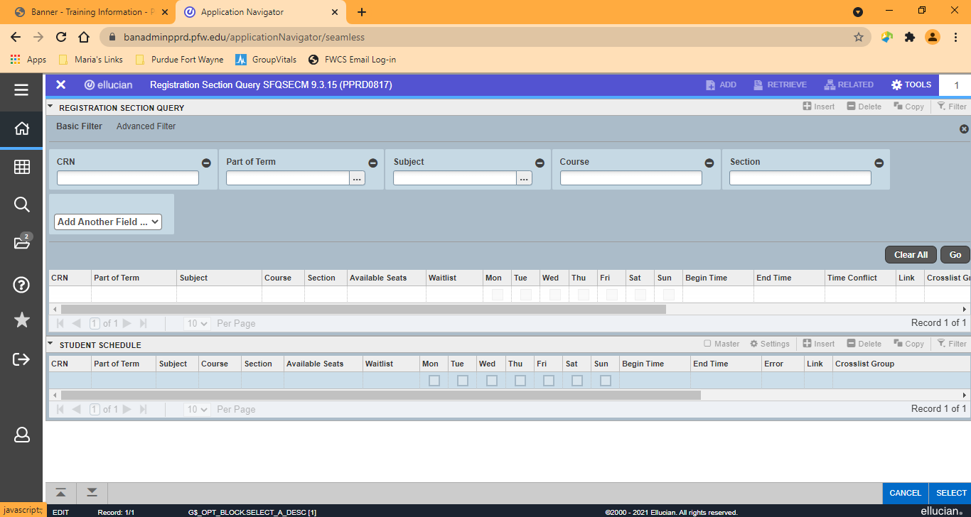

7. If you need to insert an additional CRN, click on the 

8. When you are done, click Save.

#### Dropping a Course

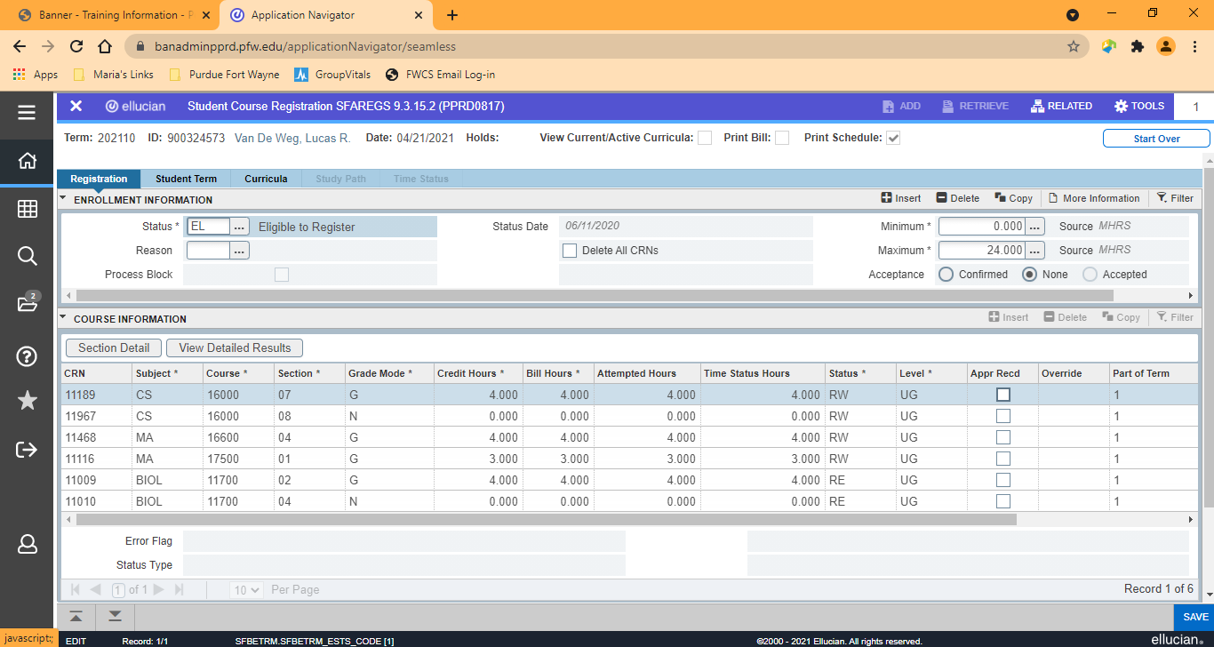

1. To drop a course, Next Block into the Course Information Block
2. To drop the course, enter DD over RE in the Status column.  
   ***Note: DD is only valid before the first day of the semester. Click the ellipses within the Status field to see valid drop codes.***
3. Click Save

**Assess Fees and Print Schedule/Bill**

1. “Y-Immediate” will appear (when rate tables are set).
2. Click Save to assess fees.
3. Click OK to complete transaction.

If you have set up your printer (sleep/wake and SOADEST) for printing schedules:

1. Make sure the “Print Bill” and “Print Sched” boxes are checked.

2. Save one more time to generate schedule/bill. To skip the   
 reports, just Start Over instead of saving.

###### Hint: To Check Registration – SFAREGQ

This form queries the student’s registration information and presents the schedule for a given term. ***Note: Use this form to see if a student is registered—not SFAREGS!***

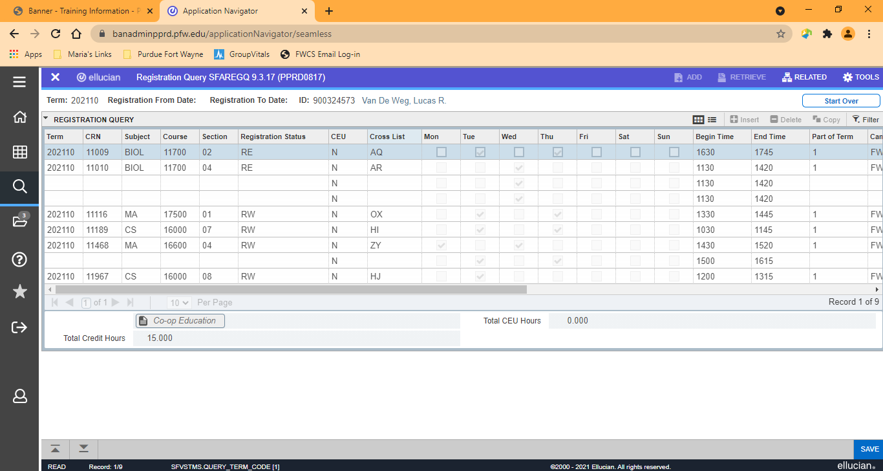

1. Enter the term code and the student ID or name
2. Press Go to roll into the student’s schedule